How to set up a MOTOROKR E6 (Emulator) Development Environment (Moto+Eclipse):

- Download and Install Java(TM) SE Development Kit 6 for Windows
- Download and Uncompress Eclipse 3.2 Java Development Tools SDK to C:\Program Files\
- Download and Install Motorola JavaTM ME SDK for Linux OS Products v6.3
- Download eclipseme.feature_1.6.6_site.zip to C:\Program Files\Eclipse\feature\
- Integrate Eclipse with Motorola simulator with following steps:
  - Run Eclipse.exe. Click Help -> Software Update -> Find and Install
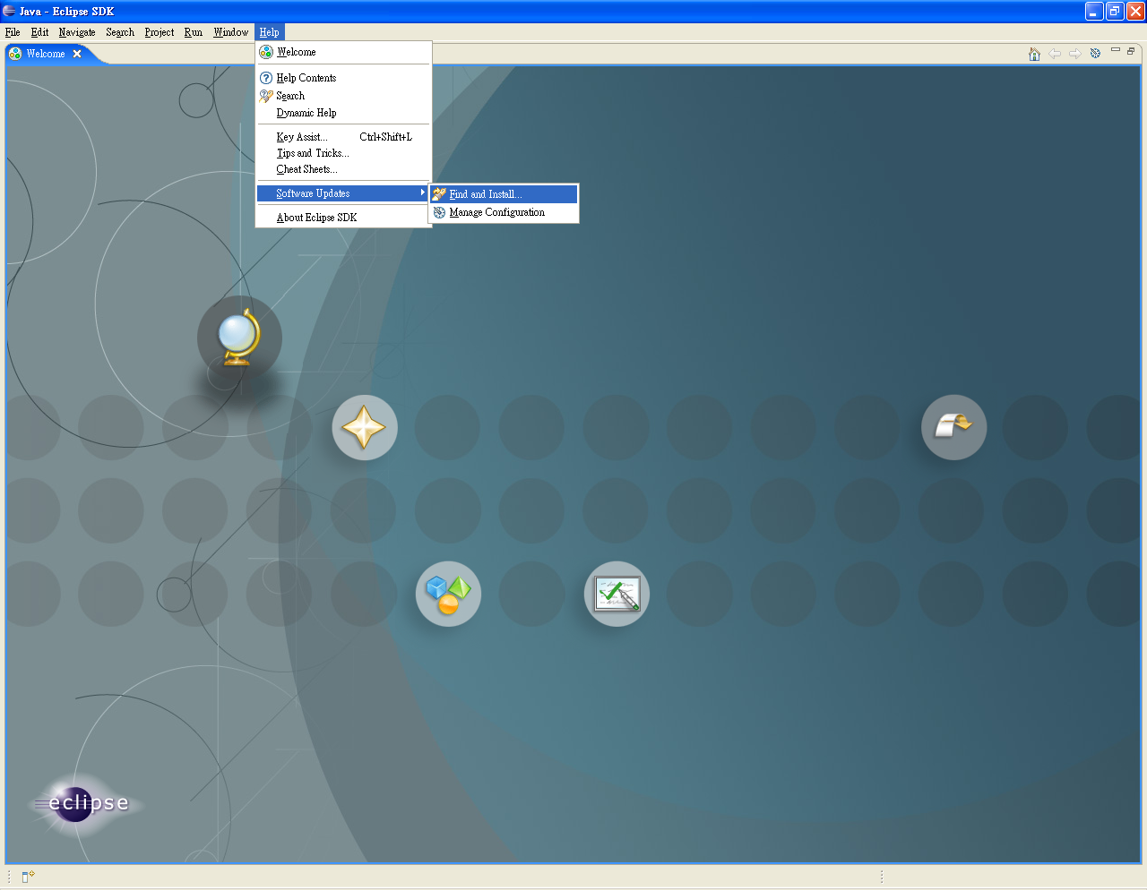
  - Check "Search for new features to install", then click Next
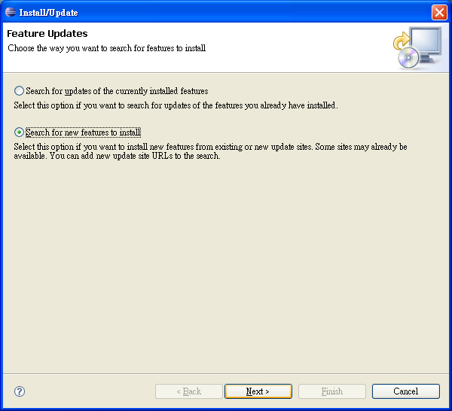
  - Click "New Archived Site…" button
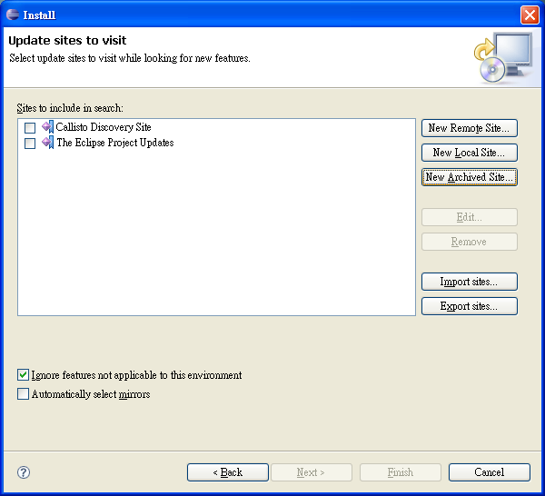
  - Select downloaded file in Step 4, then click Finish
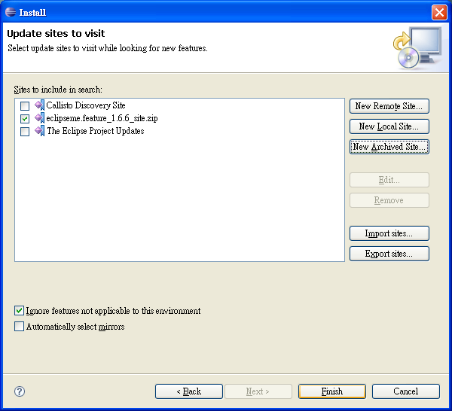
  - In Update window, Check "eclipseme.feature_1.6.6_site.zip", then click Next
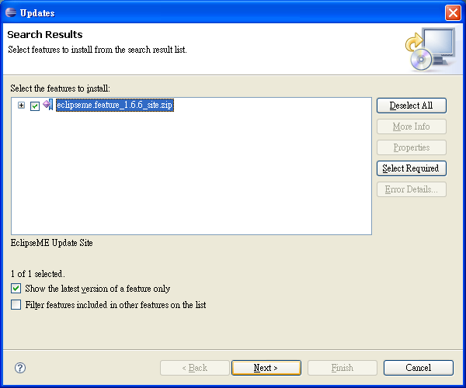

- accept the license , then click Next
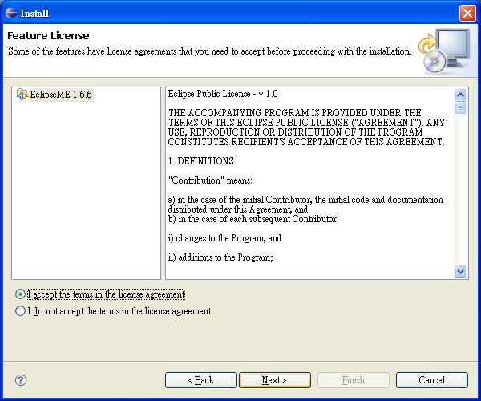
- Click Finish
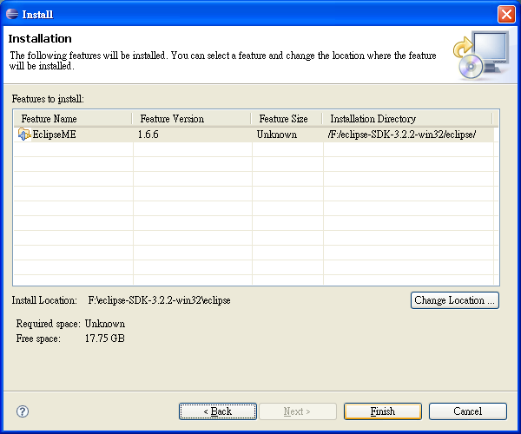
- In Verification Window, Press "Install All"
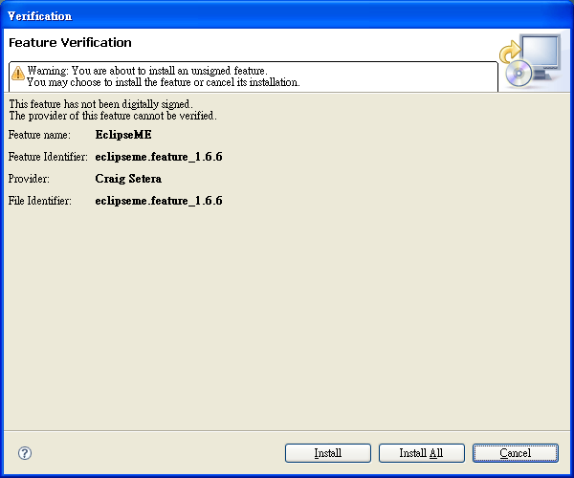
- Click "Yes" to restart your computer
Step 6: Restart Eclipse and setup emulator with following steps
- Window -> Preference
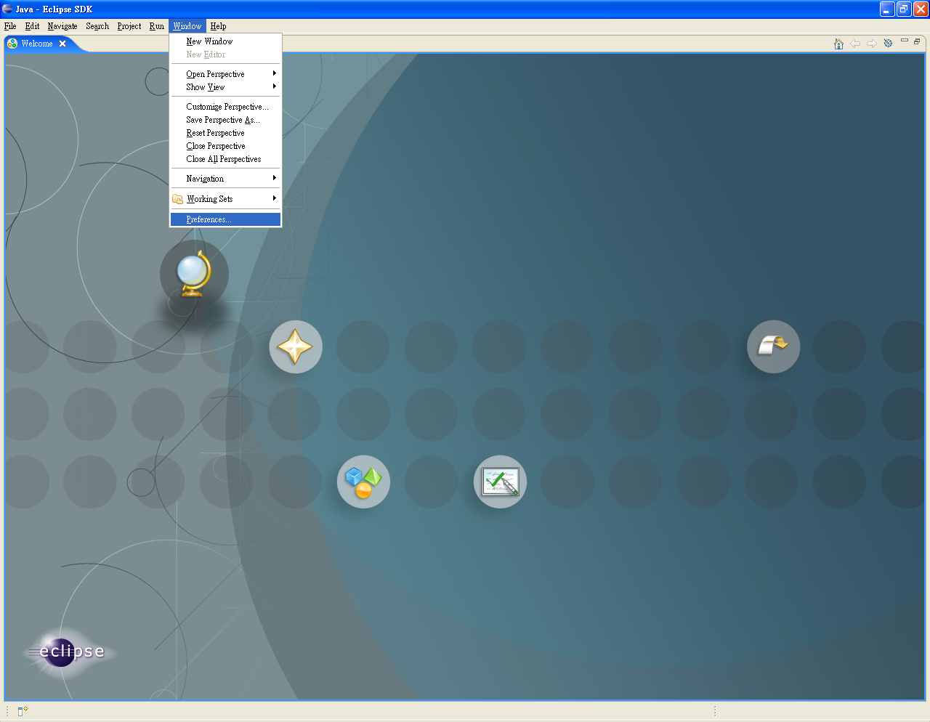
- J2ME -> Device Management -> import
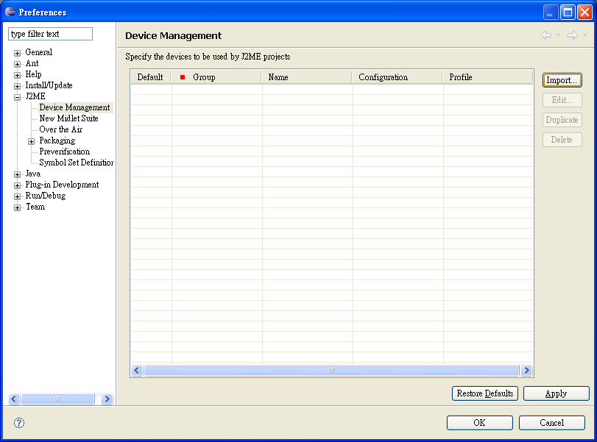
- Browse -> select C:\Program Files\Motorola\Motorola Java ME SDK v6.3 for Linux OS Products\EmulatorM.3
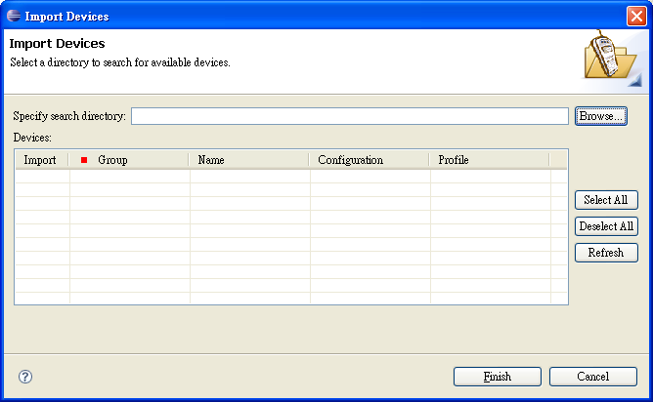
- Click Refresh button, then Finish button
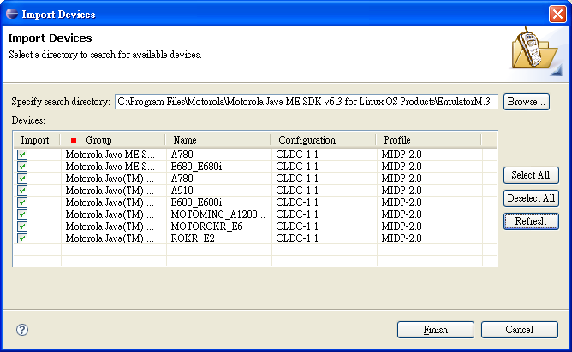
- Check MOTOROKR E6
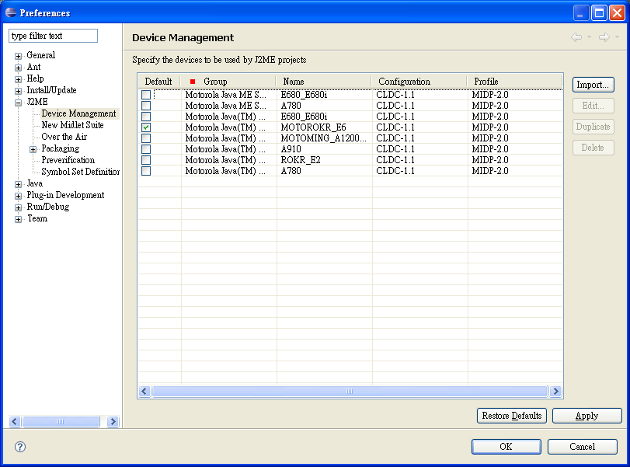

- Click OK

